ACE Device Functionality

# Core Functionality

Raspberry pi portable device that connects to a car via OBD2 and have some sort of interface so the user can see stats about their car both real-time and after the journey on a computer for more detailed information

1. Connect it to the car, go for a drive get some data together, unplug, connect to network, submit results to web server.
2. Record journeys in car with GPS (attach to raspberry pi usb)
3. Dashboard online service (upload to web server)
4. Economic Driving
5. Can check detailed information like pistons
6. Compare friends results (back end, web server)
7. Real time display what we have on the raspberry pi

# GPS Record Journeys

We intend to have a GPS receiver component as part of our device that will be able to feed co-ordinates so that a map of the route taken can be drawn. The GPS receiver will start as soon as the device is connected to the car.

This will allow us to pinpoint certain events and the colour of the route could gradually change depending on speed or how economic you were driving. This is a similar idea to the route colouring technique used in the Nike Running app:

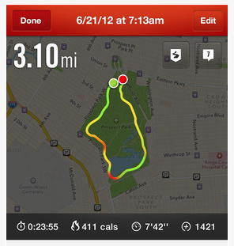

[REF] http://fitfeat.com/blog/wp-content/uploads/2013/08/nike-app.png

This would easily show where the speed was greatest or where you were driving most efficiently.  
We plan to use a digital display for the real-time information so the actual map of route taken would have to be displayed on our web interface as the digital display would not be able to handle this.

# Dashboard Online Service

The idea is that when drives have been recorded, our device can be connected to the web service and upload all the information gathered. As a user you will be able to log into the

# Economic Driving

One of the main themes of the project is economic driving and we want to be able to tell the user how economic their driving is.   
In our opinion there are two main factors in economic driving. The first is in braking too harshly; this would be represented as a sudden decrease of speed from the data collected during a drive. The idea is that speed change should be gradual and planned. This is also the case for the second factor which is whether or not you are revving too much. Over revving can be detected by comparing the rev counter value against a maximum rev

1. feedback at the end on how you could drive more efficiently
2. How much fuel you were using (in terms of cost too)

# Detailed Information

# Compared Results

# Real-time information

* 1. current mph,
  2. mpg,
  3. fuel intake
  4. gps that tracks the cars movement so you can see where the car has been
  5. where and the status of the car at any point in the journey.